The Principal,
Government Polytechnic College,
IUST,Pulwama.

No: KGP/Estt/2026/228 Dated:06-05-2026

Subject: Request for Deputation of Expert for Third Party Verification of Electrical Engineering Equipment/items on 09-05-2026.

Sir,
This institution is scheduled to undertake third-party Verification of Electrical Engineering Equipment/items on 09-05-2026 as part of quality assurance and compliance requirements, and therefore, it is kindly requested that you depute an expert from the Electrical Engineering department of your institution for verification purposes.
Your expert may please contact HOD, Electrical Engineering Department, on mobile number 9419050022 for coordination. Your prompt cooperation will be highly appreciated.

Yours Faithfully
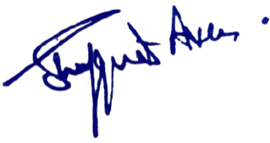

Dr. Shafquat Ara
Principal
Kashmir Government Polytechnic College
Srinagar
Copy to the :
- HOD, Electrical Engg Department for information and necessary coordination.
- Establishment/Accounts Section – for record.

